Goals

* Download and Install VirtualBox.
* Download and Install Cloudera Virtual Machine (VM) Image.
* Launch the Cloudera VM.

Instructions

Please use the following instructions to download and install the Cloudera Quickstart VM with VirutalBox before proceeding to the Getting Started with the Cloudera VM Environment video. The screenshots are from a Mac but the instructions should be the same for Windows. Please see the discussion boards if you have any issues.

1. **Install VirtualBox.** Go to [https://www.virtualbox.org/wiki/Downloads](https://eventing.coursera.org/api/redirectStrict/EKIcOOOtsOZAQ66PWs57G-2Z7j5zOjG9iJmJAUkJqW1zXHjCFvJ7eakekU_gk2OLdLOgVM1CpRG1ff5Cb9YNGw.0kQO6H0tm00EjTxE0ROPJg.9A7b5Vn-9B_qT1-YRHsZ0Mby21PnpYY1i8vN3ohOMocEaJEAiNUnihDiJ13TdBoC1rRzfMk9T6Xp_nQCCmOXrT4C0P2v8g9U93FBbzo8vCGbRL12wKRXHM9wYA1LA85DqbWXR-QKUvOScDaQGe68aDXdrBbcQ21x_qj-iL0mpPVwH1wnOCueD6xRiGWsDgDbVeuaLhDNFatwQksrLNUweUoyCEUxgCj8098WOI0SUkBgbQaYrxfUMWeluT0nDeU4nIe_xDrTkJd2qhxYfvElb6HSsneEk1L2v7WR8ZhIOT8cnprQ-0bVUx8m4YD9VYaIwKyySPJu59RQCEfA4PdMCQ) to download and install VirtualBox for your computer.

2. **Download the Cloudera VM.** Download the Cloudera VM from

<https://downloads.cloudera.com/demo_vm/virtualbox/cloudera-quickstart-vm-5.4.2-0-virtualbox.zip>

The VM is over 4GB, so will take some time to download.

3. **Unzip the Cloudera VM**:

Right-click cloudera-quickstart-vm-5.4.2-0-virtualbox.zip and select “Extract All…”

4. **Start VirtualBox**.

5. **Begin importing**. Import the VM by going to File -> Import Appliance

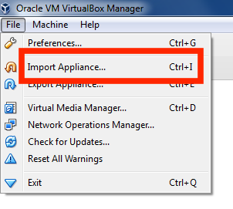

6. **Click the Folder icon.**

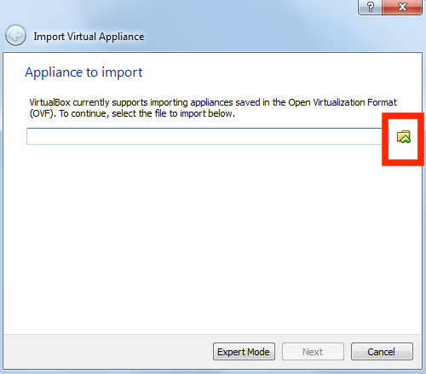

7. **Select the cloudera-quickstart-vm-5.4.2-0-virtualbox.ovf** from the Folder where you unzipped the VirtualBox VM and click Open.

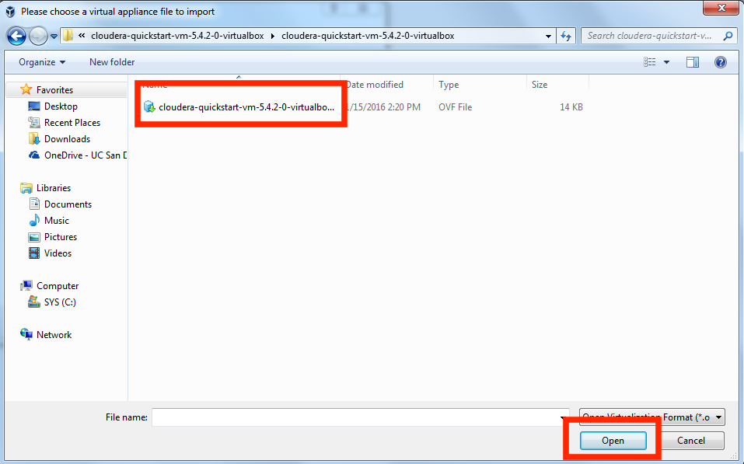

8. **Click Next** to proceed.

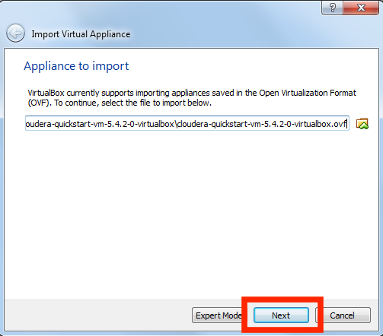

9. **Click Import.**

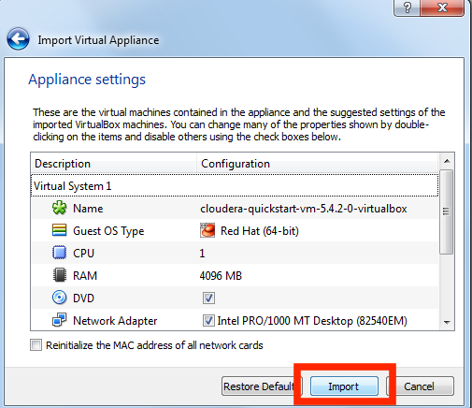

10. **The virtual machine image will be imported.** This can take several minutes.

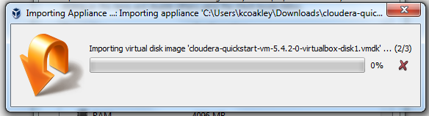

11. **Launch Cloudera VM.** When the importing is finished, the quickstart-vm-5.4.2-0 VM will appear on the left in the VirtualBox window. Select it and click the Start button to launch the VM.

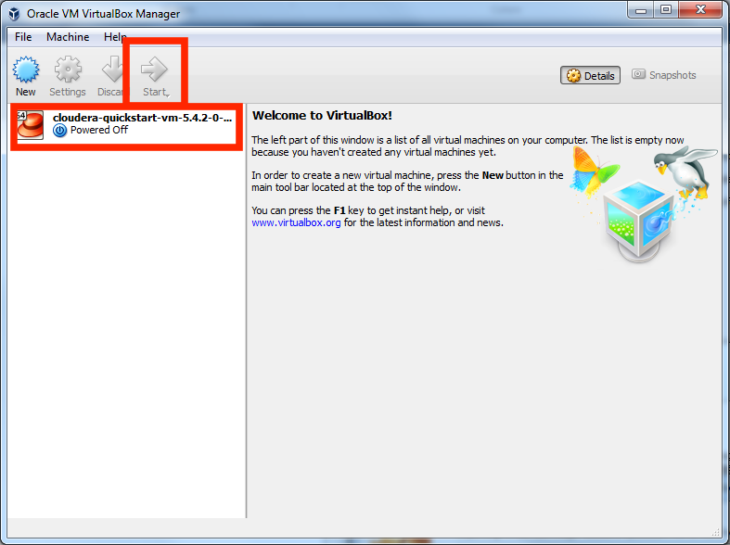

12. **Cloudera VM booting.**It will take several minutes for the Virtual Machine to start. The booting process takes a long time since many Hadoop tools are started.

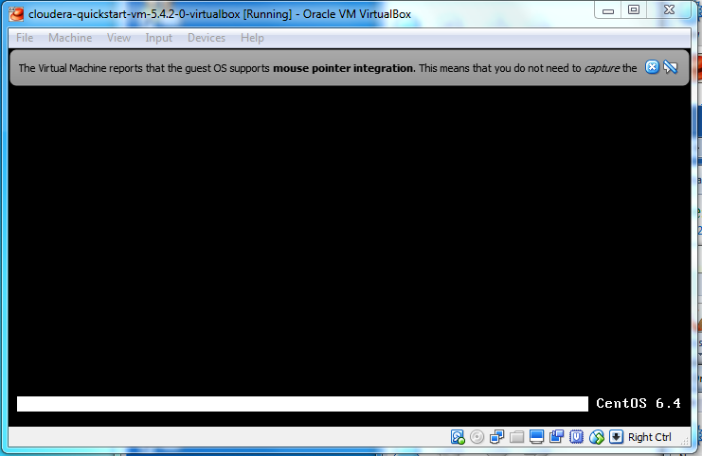

13. **The Cloudera VM desktop.**Once the booting process is complete, the desktop will appear with a browser.

